**Practical: 5**

**Que:1 Create an event emitter instance and register a listener which calculates current date and time and display greeting based on time.**

const event = require('events');

const e = new event.EventEmitter();

e.on('clicked',function(){

    const date = new Date()

    var hour = date.getHours();

    var min = date.getMinutes();

    console.log("Today Date is: "+date.getDate()+

"-"+(parseInt(date.getMonth())+1)+"-"+date.getFullYear());

    if(hour >= 12)

    {

        console.log("Current Time: "

+(hour%12)+":"+min+":"+date.getSeconds()+" PM");

    }

    else{

        console.log("Current Time: "

+(hour%12)+":"+min+":"+date.getSeconds()+" AM");

    }

    if(hour>=6 && hour<=11 && min>=0 && min<=59)

    {

        console.log("Good Morning");

    }

    else if(hour>=12 && hour<=15 && min>=0 && min<=59)

    {

        console.log("Good Afternoon");

    }

    else if(hour>=16 && hour<=19 && min>=0 && min<=59)

    {

        console.log("Good Evening");

    }

    else

    {

        console.log("Good Night");

    }

});

e.emit('clicked');

**Output:**



**Que:2 Create an event and register two listeners to perform sum of two values with different arguments (use different data types).**

const event = require('events');

const e = new event.EventEmitter();

e.once('event-1',(num1,num2)=>{

    console.log("Sum of two number is: "+(num1+num2));

});

e.once('event-2',(num1, num2,num3)=>{

    console.log("Sum of three number is: "+(num1+num2+num3));

});

e.emit('event-1',10,20);

e.emit('event-2',10,20.25,35);

**Output:**

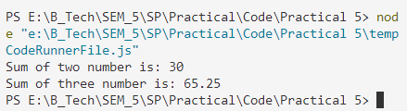

**Que:3 Create event which performs following tasks synchronously:**

1. Read file content
2. Display content of file
3. Find out number of words
4. Display numbers of words and finishing message const event = require('events');

const fs = require('fs');

const e = new event.EventEmitter();

e.once('event-read',(fname)=>{

    fs.readFile(fname,function(err,data){

        if(err)

        {

            console.log(err.message);

        }

        else{

            console.log("=====File Data is=====\n")

            console.log(data.toString()+"\n");

            e.emit('event-word-cal',data.toString());

        }

    });

});

e.once('event-word-cal',(data)=>{

    var str = data.replace('\r\n',' ').split(' ');

    console.log("No of word in file is: "+(str.length));

    console.log("Finish");

});

e.emit('event-read','./p5_3.txt');

**Output:**

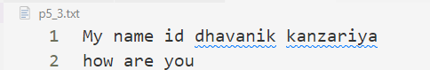

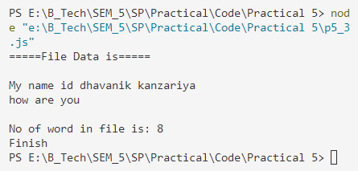

**Que:4 Do as directed:**

1. Remove a specific listener.
2. Remove all listeners.
3. How to get the maximum size of listener that will bind with a specific event?
4. How to change the maximum size of listeners to bind with specific events?
5. Find out the name of active listeners for the specified event.
6. Find out the number of listeners listening to the specified event.
7. How to change the execution position of listeners?

const EventEmitter = require('events');

var eventEmitter = new EventEmitter();

var f1= (msg) => {

    console.log("Message from f1: " + msg);

};

var f2 = (msg) => {

    console.log("Message from f2: " + msg);

};

var f3 = (msg) => {

    console.log("Message from f3: " + msg);

};

eventEmitter.on('myEvent', f1);

eventEmitter.on('myEvent', f2);

eventEmitter.on('myEvent', f2);

//Change the execution position of listener by using prependListener

eventEmitter.prependListener('myEvent', f3);

//get name of all active listener

console.log("The name of event is: ",eventEmitter.eventNames());

//get number of listeners listening to the specified

console.log("\nNumber of listeners listening to the specified event")

console.log("No of listeners is: "+eventEmitter.listenerCount('myEvent'))

//Remove a specific listener.

eventEmitter.removeListener('myEvent', f1);

console.log("\nf1 Listener Removed");

eventEmitter.emit('myEvent', "Event occurred");

//Remove all listeners.

eventEmitter.removeAllListeners('myEvent');

console.log("\nAll Listener Removed\n");

eventEmitter.emit('myEvent', "Event occurred");

//get maximum size of listener

console.log("-----Default Maximum size of listeners-----")

console.log("Maximum size of listener is: "+eventEmitter.getMaxListeners())

//set maximum size of listener

eventEmitter.setMaxListeners(15);

console.log("-----Maximum size of listeners after bind-----")

console.log("Maximum size of listener is: "+eventEmitter.getMaxListeners())

//get name of all active listener

console.log("\n-----The name of active listeners is empty because we remove all listener-----");

console.log("The name of event is: ",eventEmitter.eventNames());

//get number of listeners listening to the specified event after remove it

console.log("\n-----Number of listeners listening to the specified event is Zero because we remove all listener-----")

console.log("No of listeners is: "+eventEmitter.listenerCount('myEvent'))

**Output:**

